GOVERNMET NAVEEN COLLEGE - GURUR
DISTRICT – BALOD (C.G.), INDIA
Contact No : 07749 – 265461 Email : gururgovernmentcollege@gmail.com Website : www.gcgurur.org.in

Plants in Our Green Campus
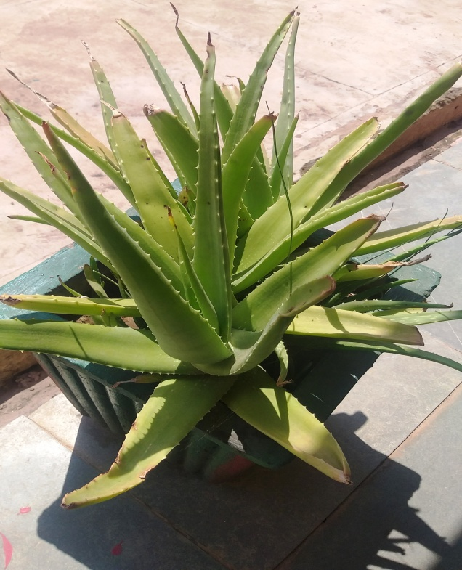  01  Common Name – ?k`rdqekjh  Botanical Name – Aloe Vera | 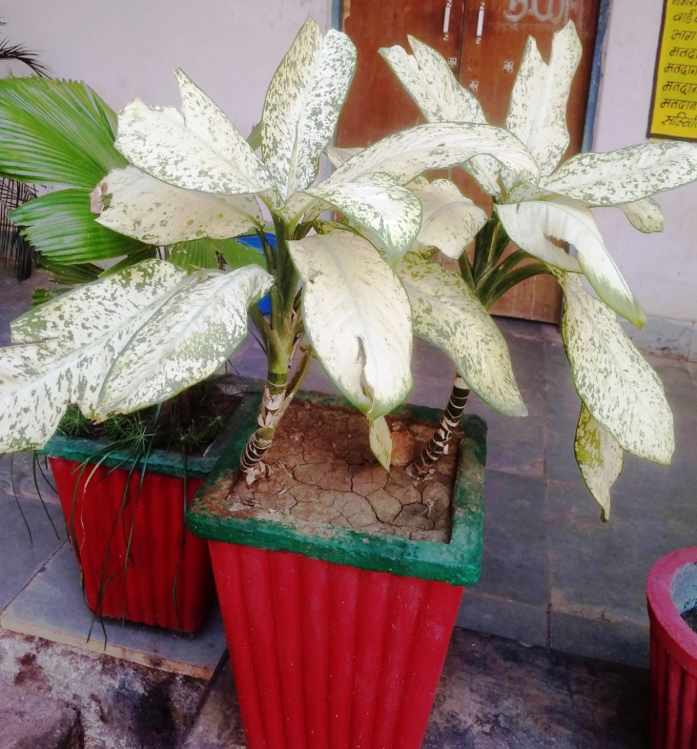  02  Common Name – Dumb Cane  Botanical Name – Dieffenbachia Sequin
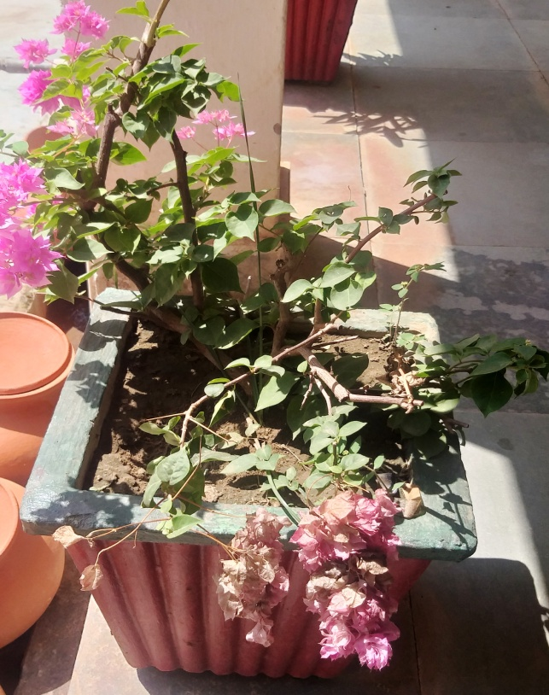  03  Common Name – Paper Flower  Botanical Name – Bougainvellea | 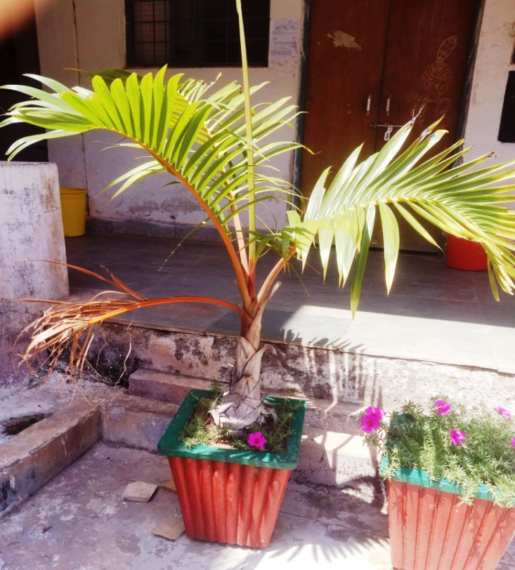  04  Common Name – Areca Palm  Botanical Name – Dupsis Lutescens
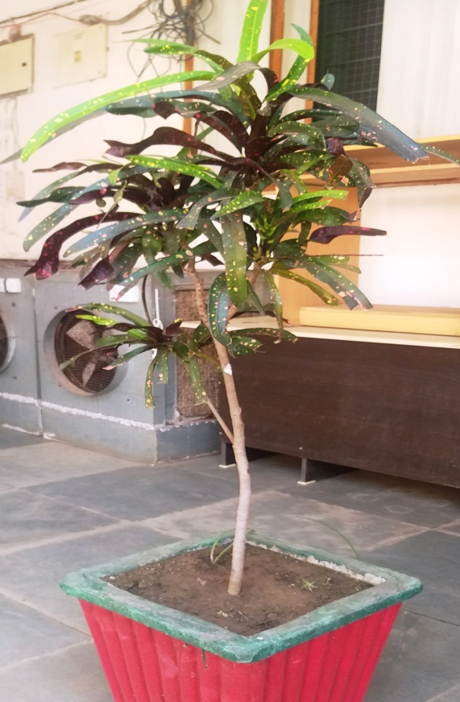  05  Common Name – Variegated Croton  Botanical Name – Codiacum Variegatum | 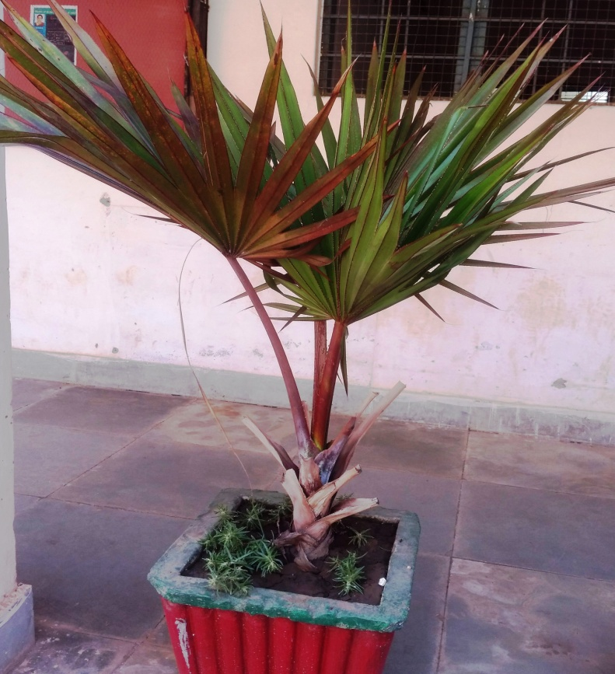  06  Common Name – Chinese Fan Palm  Botanical Name – Livistona Chinensis
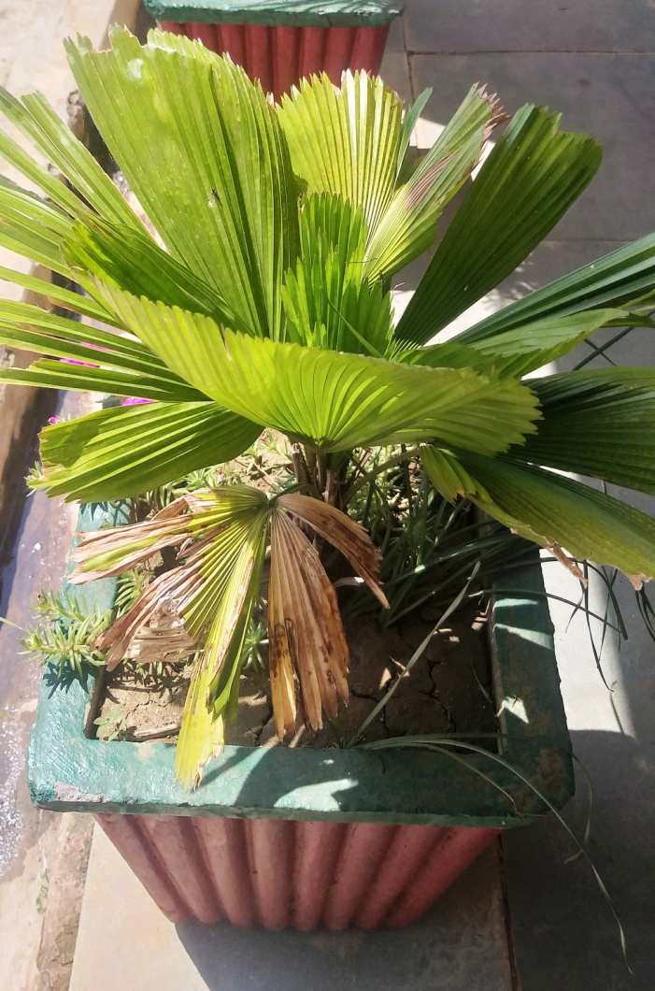  07  Common Name – European Fan Palm  Botanical Name – Chamaerop Humilis | 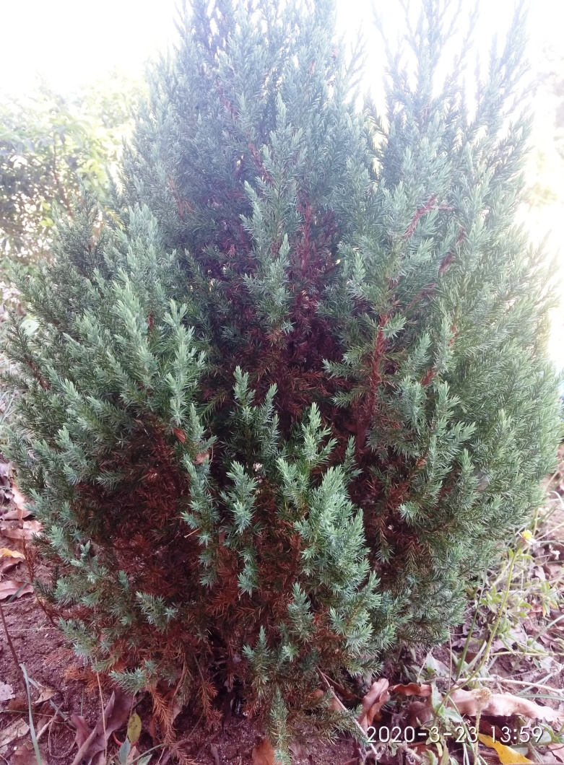  08  Common Name – Eastern Red Cedar  Botanical Name – Juniperus Virginiana L.
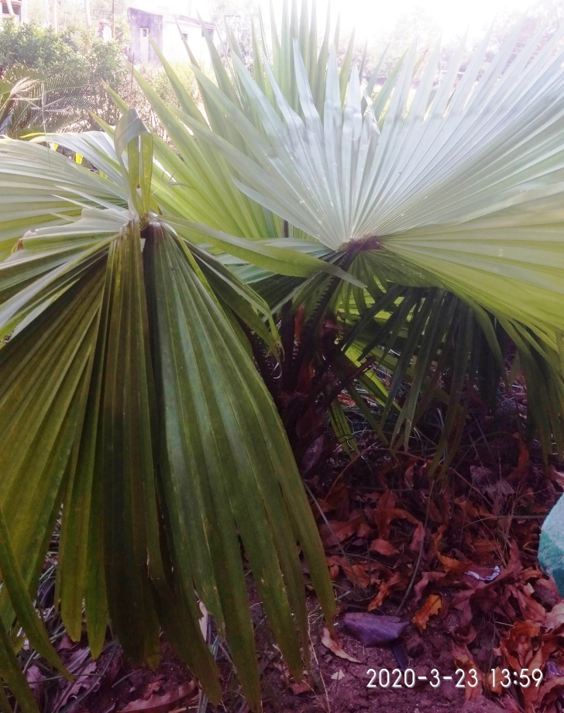  09  Common Name – Washington Fan Palm  Botanical Name – Washingtonia Robusta | 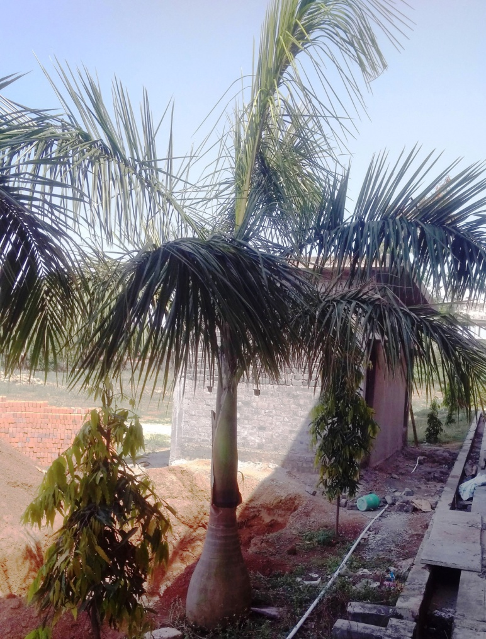  10  Common Name – Royal Palm  Botanical Name – Roystonea Regia
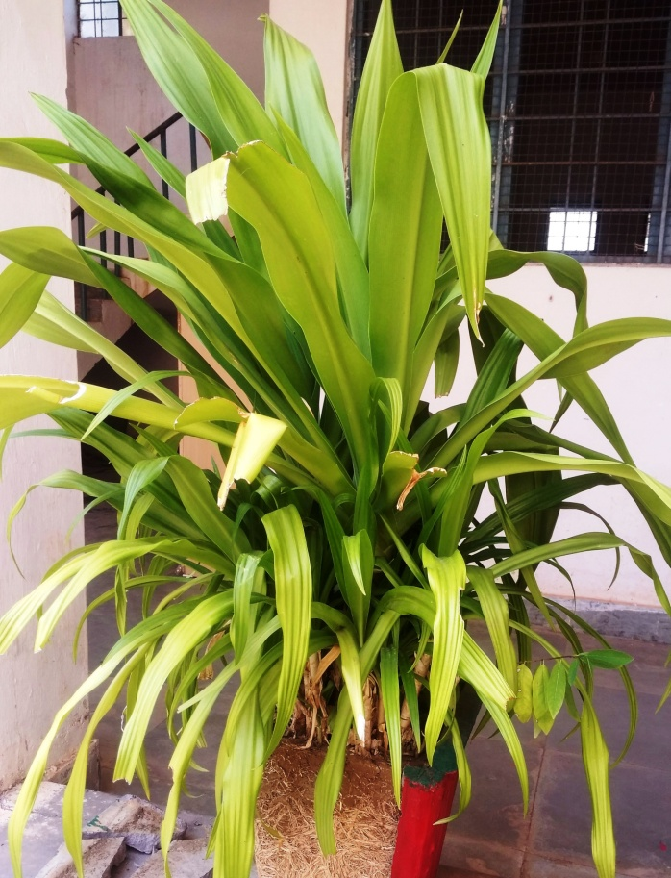  11  Common Name – Poison Bulb  Botanical Name – Crinum Asiaticum L. | 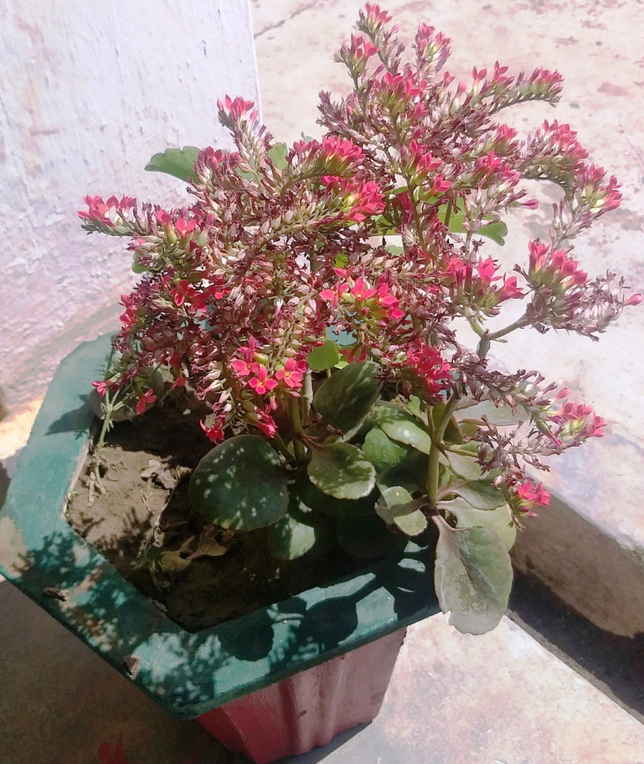  12  Common Name – Madagascar Window  Botanical Name – Kalanchoe Blossfeldiana
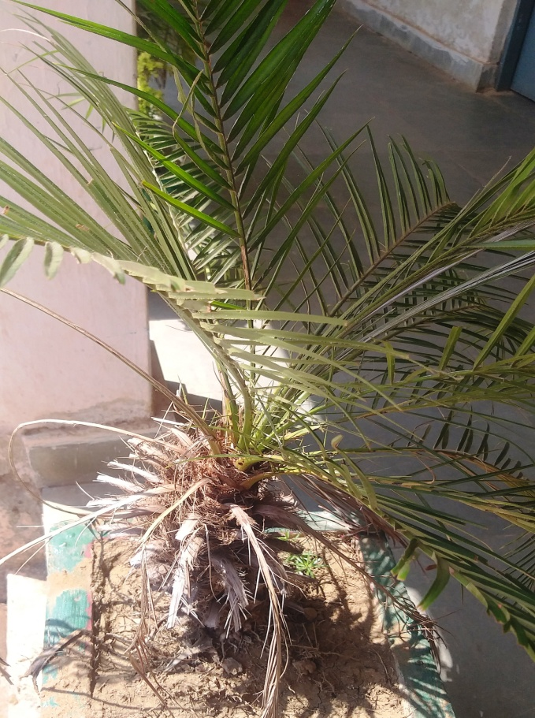  13  Common Name – Canary Isoland Date Palm  Botanical Name – Pheonix Canariensis Chabaud | 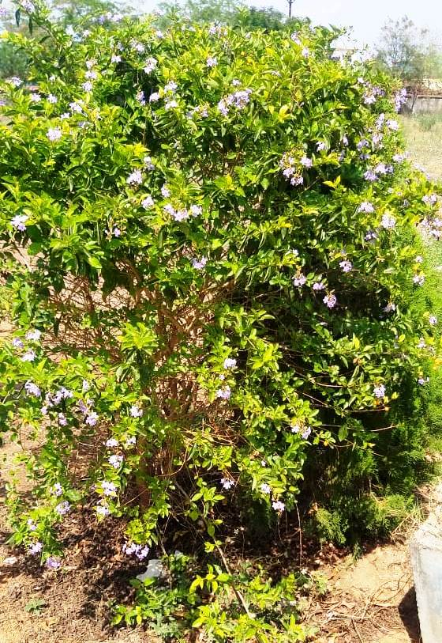  14  Common Name – Green Dewdrops  Botanical Name – Duranta Eracta
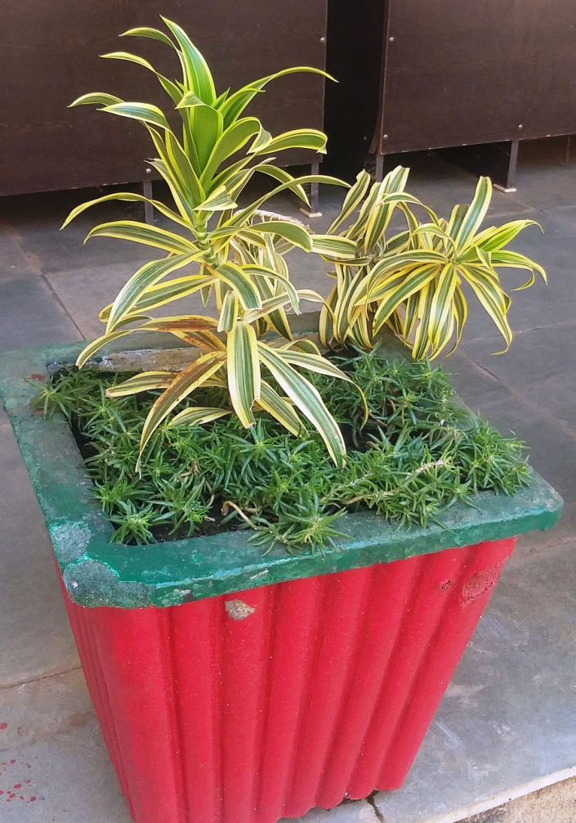  15  Common Name – Song of India  Botanical Name – Dracaena Reflexa Lam. | 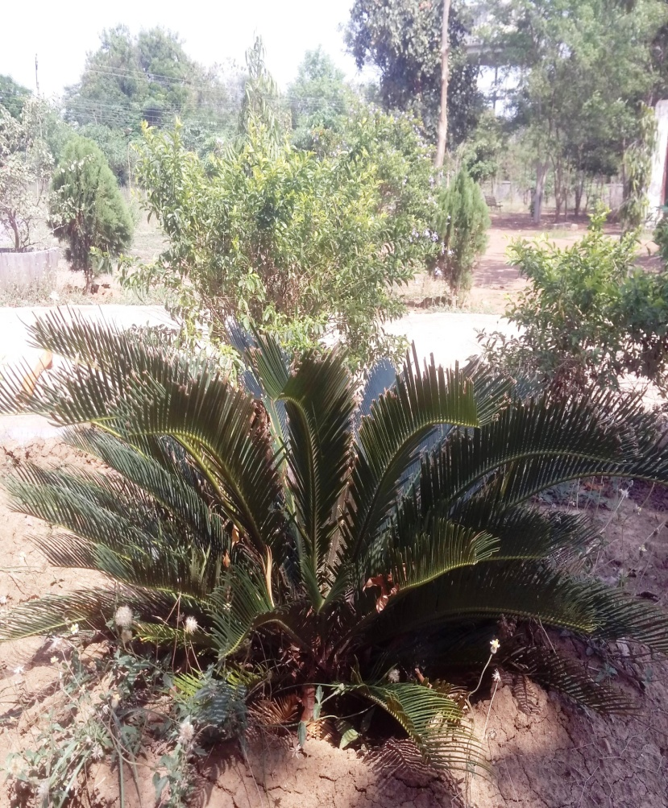  16  Common Name – Sago Palm  Botanical Name – Cycus Revoluta
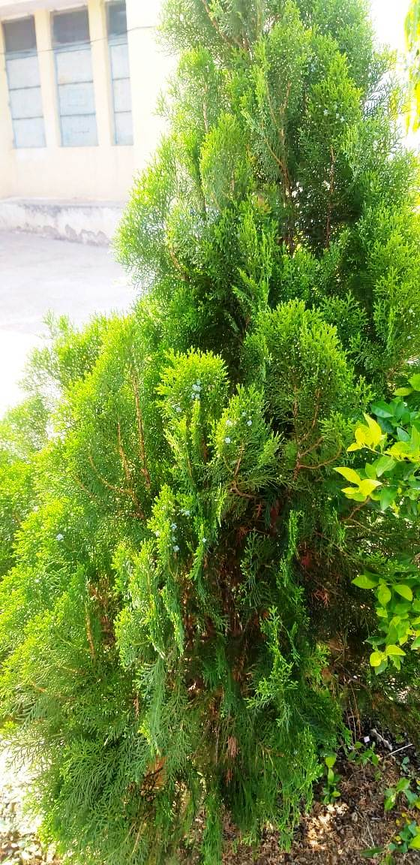  17  Common Name – fo|k iRrh  Botanical Name – thuja Occidentalis | 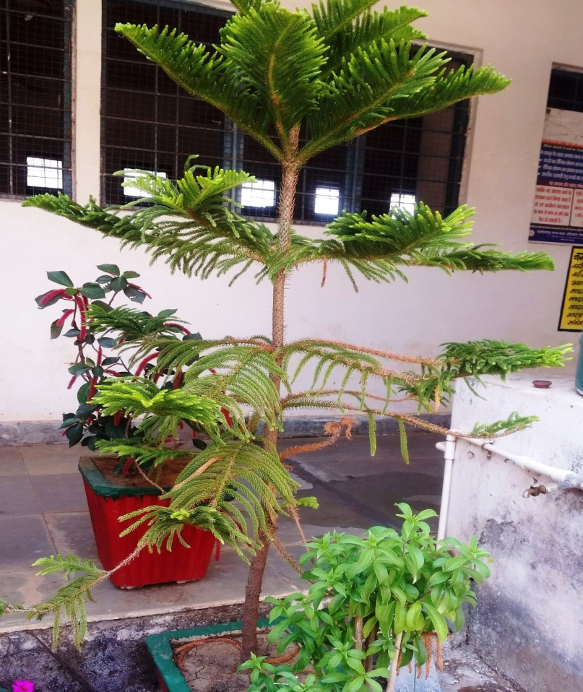  18  Common Name – fØlel Vªh  Botanical Name – Araucaria Heterophylla
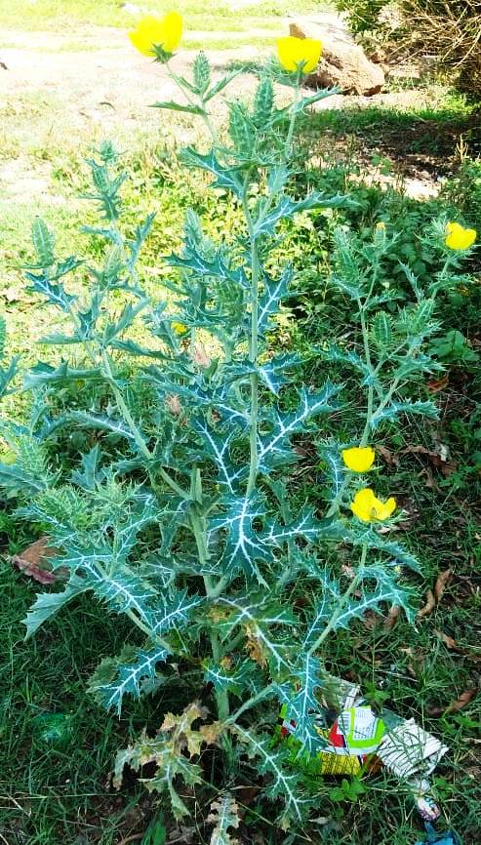  19  Common Name – ihyh dVsjh (Mexican Poppy)  Botanical Name – Argemone Mexicana | 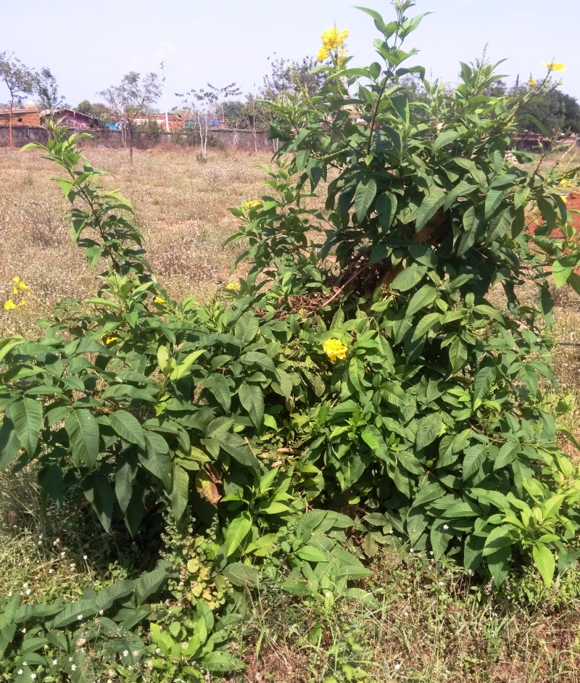  20  Common Name – Trumpet Flower  Botanical Name – Tecoma Stans (L.)
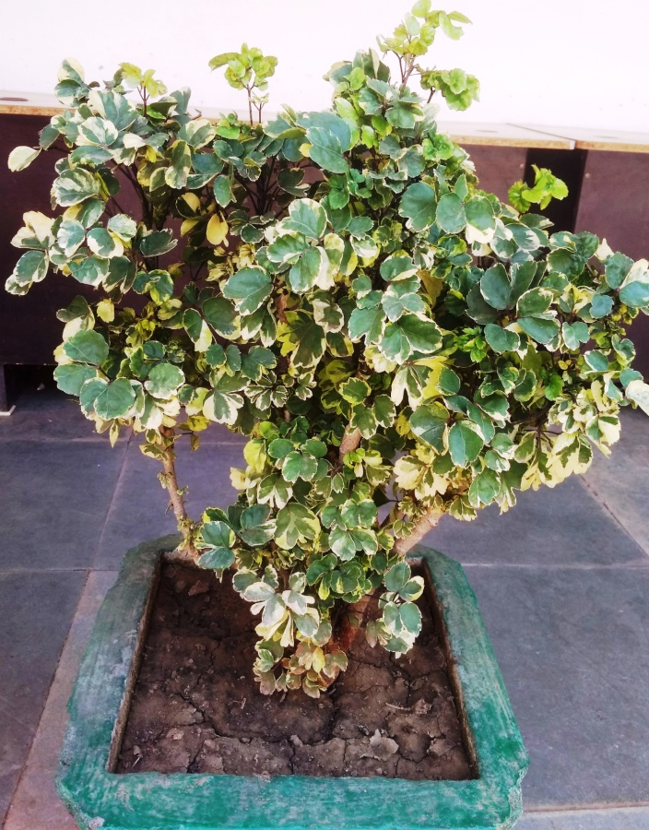  21  Common Name – tsjsfu;e vjSfy;k  Botanical Name – Polyscias Guilfoylei | 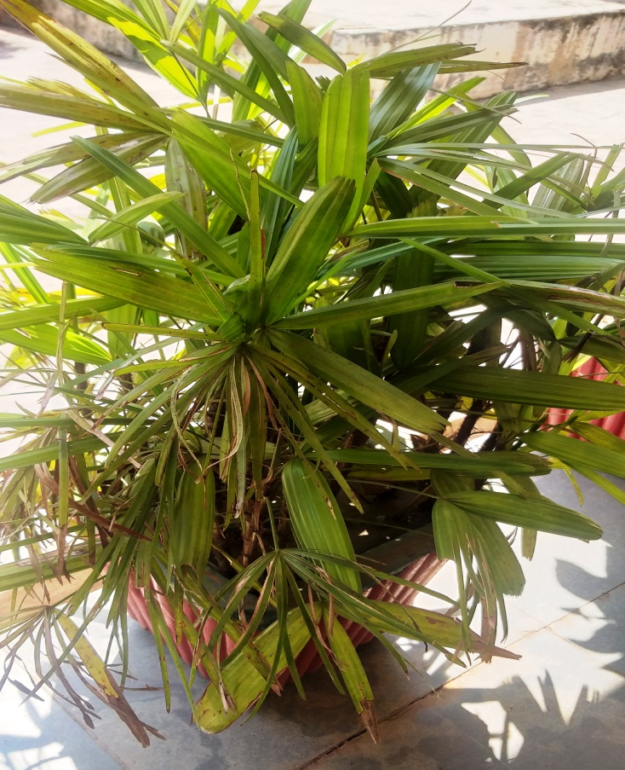  22  Common Name – Bamboo Palm  Botanical Name – Rhapis Excelsa
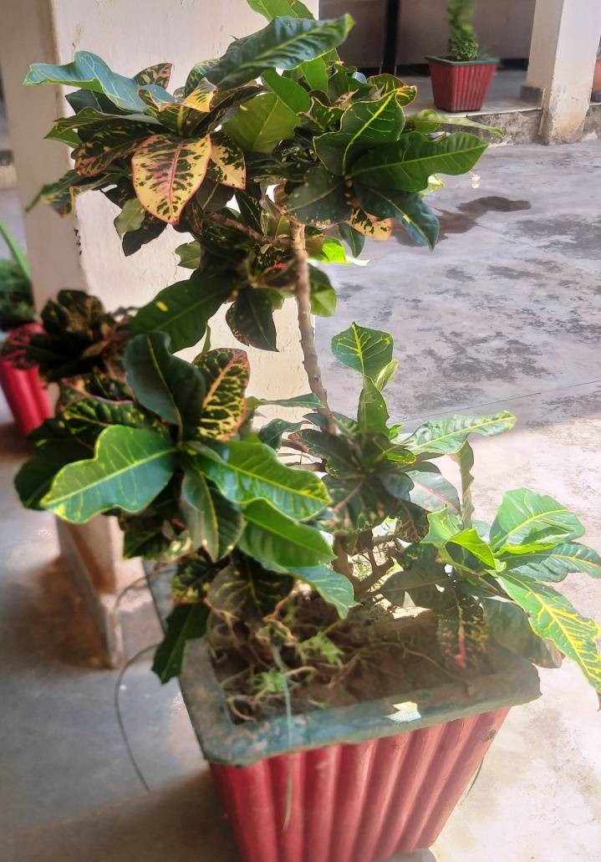  23  Common Name – Croton  Botanical Name – Codiacum Variegation | 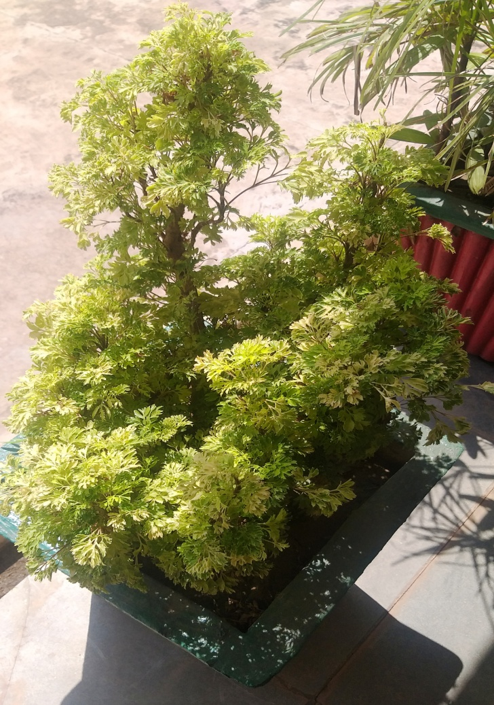  24  Common Name – Teatree  Botonical Name – Polyscias Fruticosa
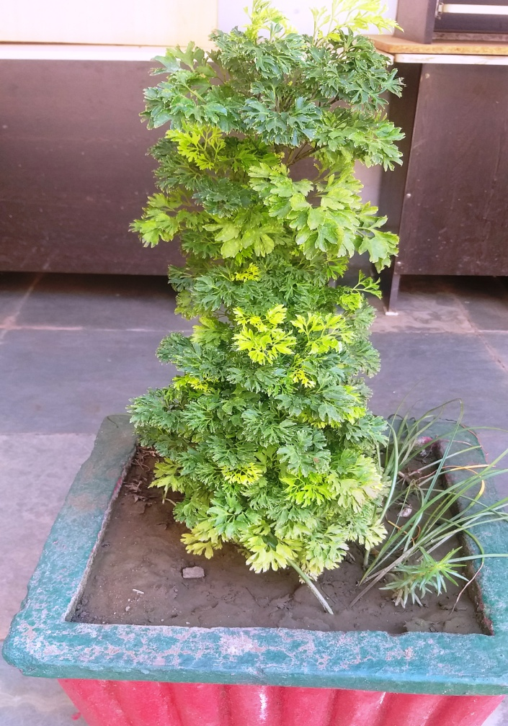  25  Common Name – Smallage  Botanical Name – Apium Travellers L. | 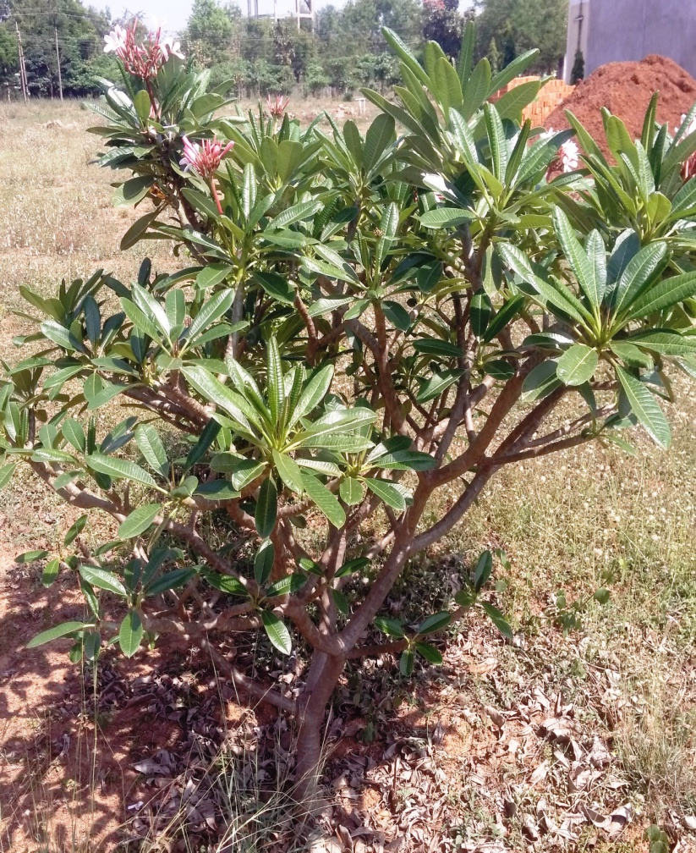  26  Common Name – yky xqykfpu  Botanical Name – Plumeria Rubra
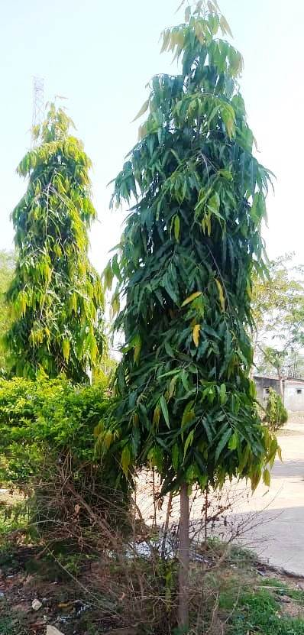  27  Common Name – Ashoka (Cemetery Tree)  Botanical Name – Polyalthia Longifolia | 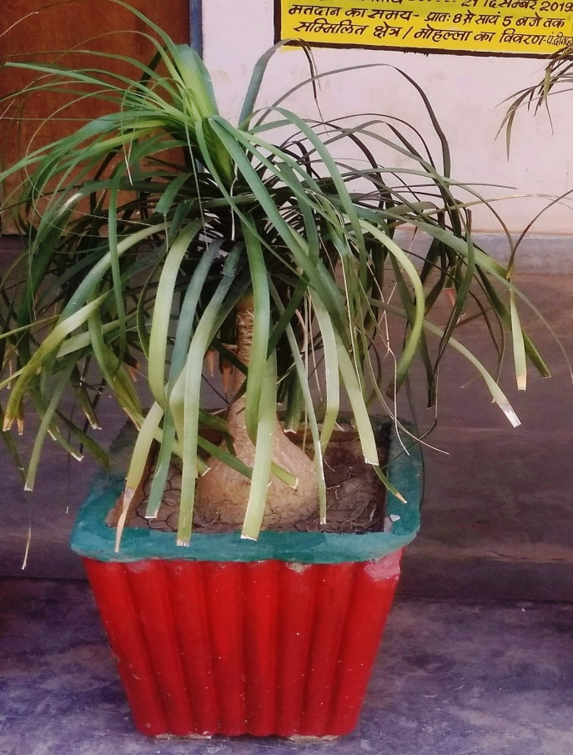  28  Common Name – Bottle Palm  Botanical Name – Beaucarnea Recurvata Lem.
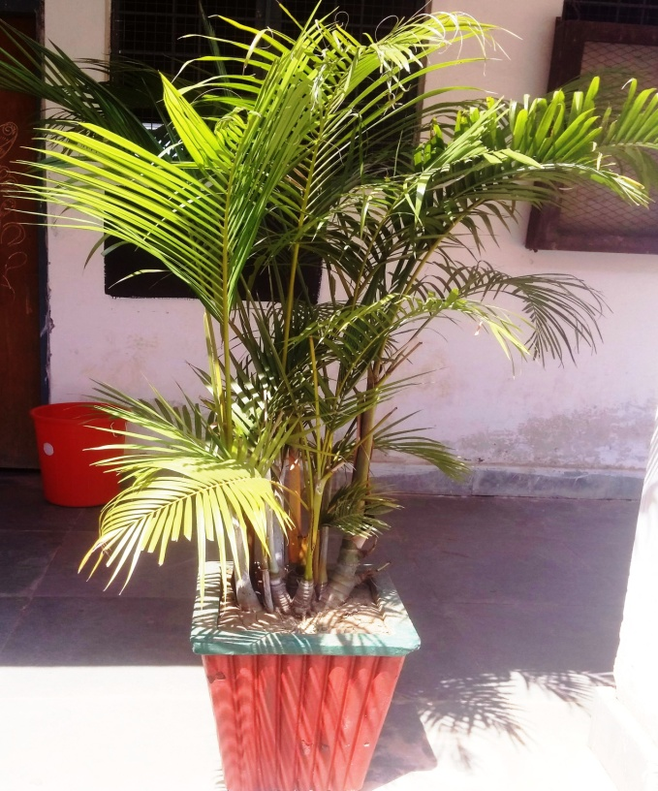  29  Common Name – Kentia Palm  Botanical Name – Howea Forsteriana | 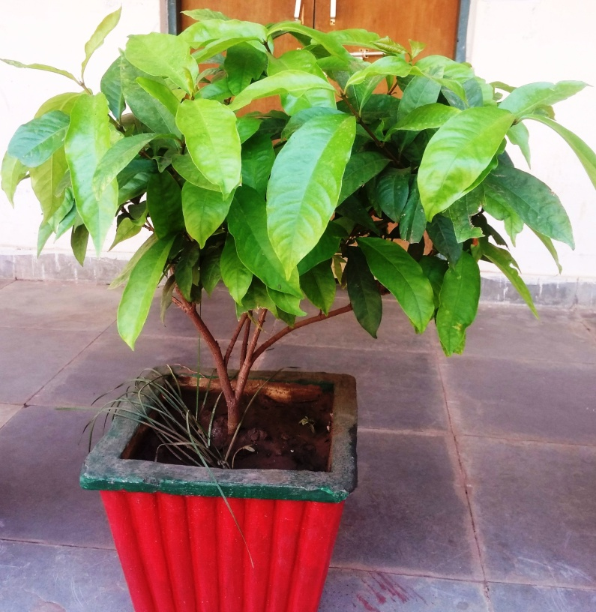  30  Common Name – Jungle Flame, Hindi Name – :xfeuh  Botanical Name – Ixora Cocina L.

Thank You . . .

